|  |  |
| --- | --- |
|  | **CROATIAN PHYSIOLOGICAL SOCIETY**  *Šalata 3B, 10 000 Zagreb*  *contact: aleksandra.dugandzic@mef.hr* |

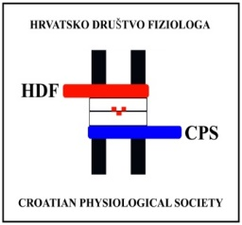**Registration Form**

**For the 18th Annual symposium of the Croatian Physiological Society with international participation (School of Medicine, University of Zagreb, Croatia, October 17 th – 18 th, 2025)**

**Personal information**

Name:

Surname:

Title:

Institution:

Country:

Address:

E-mail:

**Registration** *(Please mark the preferred option)*

I would like to register:

1. **As member of the Croatian Physiological Society**

Registration fee is waived

1. **As non-member of the Croatian Physiological Society**

Registration fee: 40,00 €

**Participation**

Please select preferred type of participation in the conference:

1. Oral presentation
2. Poster presentation
3. Passive participation

I give my consent for publishing my abstract online (Yes/No)?

**Conference dinner,** October 17th, 2025 (Friday)(place TBA)

* 1. Yes
  2. Yes - accompanying person
  3. No

**Allergies and dietary restrictions**

If you have any food-related allergies or dietary restrictions, please list them and we will do our best to accommodate them. If you are bringing an accompanying person, please note their allergies as well.

Allergies: ______________________________________________________

Dietary restrictions: ______________________________________________

Date: Signature: